Abstract

Computer games have been a growing popularity in the last decade. Adventure games is one of the prime categories in this list. Our treasure hunt game is an interactive program which works with user inputs. For this game, we will establish the directions in which the player can move, a way to track how far the player has moved (and therefore which room he/she is in), and to print out a description. We will also set limits for how far the player can move. In other words, create “walls” around the rooms that tell the player, “You can’t move further in this direction.” This version of the game we are releasing as version 1.0 with room for more versions to come. The future prospects of this game include interaction with objects or other people, a more complicated virtual layout of rooms, a realistic design display.

Contents

Sl. No. | Details | Page No.
1 | Introduction | 1
2 | Analysis | 3
3 | Design (UML diagrams) | 4
4 | Technologies used | 6
5 | Implementation | 7
 | 5.1 Modules
 | 5.2 Sample code
 | 5.3 Screen shots
6 | Conclusion and Scope for future enhancements | 13
 | References | 14

- INTRODUCTION

  - Introduction

Our main objective was to build a treasure hunt game. Instead of making a boring text based game, because, let’s face it, nobody would want to play that, we made a full fledged adventure series game with its own set of graphics and music track. We now call it a product of STeP. This name is a combination of the first letters of the three group members of this project and the final E is for Evolution. Got a ring to it, isn’t it.

  - Aim and scope of the project

A treasure hunt game is a fun adventure based game. Instead of an ordinary treasure finding game, the aim of our treasure hunt game is slightly different – you don’t know what you’re searching for. Sounds strange? Well that’s the plot twist.

The game consists of our player Bucky, who is a tiny little thing you’ll like instantly. He calls himself forgetful and having lost something in the map maze, he seeks your help in finding it, never telling you what it might be, for the simple reason that he doesn’t remember so! So now your aim is to scour through the maze to find something that could possibly belong to Bucky.

  - About Existing system

Our project was developing a Treasure Hunt game by learning Python. But 2 weeks into the project, we realized that for visual applications like games, better software substitutes are available. Thus our search began and landed on Phaser. Phaser is a free software 2D game framework for making HTML5 games. It is easy to learn and make games.

  - Detail description of the proposed system

Our project is launched as a web application. With the help of HTML and a web server, we host our game. Phaser framework provides a canvas where our game contents load, it’s basically a stage where the users play the game.

  - System requirements (Software and Hardware)

The software requirements of our project are Javascript, Phaser 3 framework and of course, HTML5. We also use the chrome extension Web server for Chrome to host our local web pages using HTTP.

- Phaser framework- Phaser is a free software 2D game framework for making HTML5 games for desktop and mobile.

- JavaScript- JavaScript is a scripting language used in the HTML files to create functions , modify the content of the webpage(create, delete, update make it interactive) etc…

- HTML5- HTML5 is a markup language that is widely used to create web pages. The HTML tags are hidden keywords that defines and formats the content of the browser.
- A Web Server for Chrome, serves web pages from a local folder over the network, using HTTP so we can run the project offline.

2. ANALYSIS OF PROJECT

2.1 Technical Feasibility

Treasure hunt game is made of simple build. It is an easy to play game with simple UI. This game appeals to people of all ages, anyone with a notion of adventure can play this game. You don't need any special software or hardware skills to play, just normal usage of a computer. The controls are minimized. The mouse is used to navigate across the webpage and the arrow buttons can be used to play the game.

The four arrow buttons mark the four directions the player can move: left, right, up and down. The player can traverse the entire canvas of the game. The player speed is medium paced, he can reach from one end of the map to the other within 30 seconds.

The technical grounds of this project are sound and easy to learn. We have utilized many different technical concepts from them.

Canvas:- The HTML <canvas> element can be used to draw graphics via scripting in
JavaScript. For example, it can be used to draw graphs, make photo compositions, create animations, or even do real-time video processing or rendering. A page can effectively add support for <canvas> by including a script from Google's Explorer Canvas project. Google Chrome and Opera 9 also support <canvas>The <canvas> element is also used by WebGL to draw hardware-accelerated 3D graphics on web pages,

Game constructor:- This is where the magic happens. The Game object is the heart of your game, providing quick access to common functions and handling the boot process. During the setup we included the Phaser library in our HTML file. This gives us a global object
called Phaser.

Through it, we can access the library's methods and functions for building!
games. Now we will use the global Phaser object, and create a new game instance. This is
an object which represents our entire game. We will add the states to it.

States:- This is a base State class which can be extended if you are creating your own
game. It provides quick access to common functions such as the camera, cache, input, match, sound and more. There are three main states namely, preload(), create(), and update(). There is also a fourth state commonly used which is named debug or renderer.

3. DESIGN

3.1 Game layout
The treasure hunt game is mapped as a grid. All the components are placed on the map with respect to this grid. This helps in tracking the movement of the player and his proximity to the treasure. The grid layout has three outcomes: one, the player reaches the treasure without disturbance and wins the game, the player intercepts a baddie, dies and the game ends or if the player reaches an end of the map layout, the game engine automatically turns him around and back into the interiors.

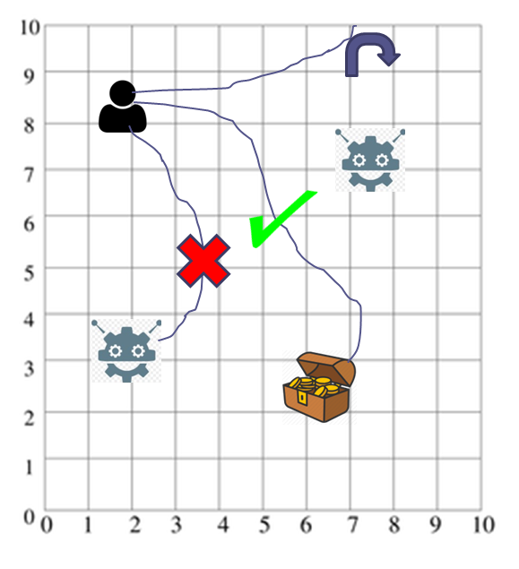
Figure 1: Grid layout

3.2 Use Case Diagram

Our use case diagram consists of the actors: player, database and game engine. They are involved in roles like playing the game, storing player details and generating game components respectively.

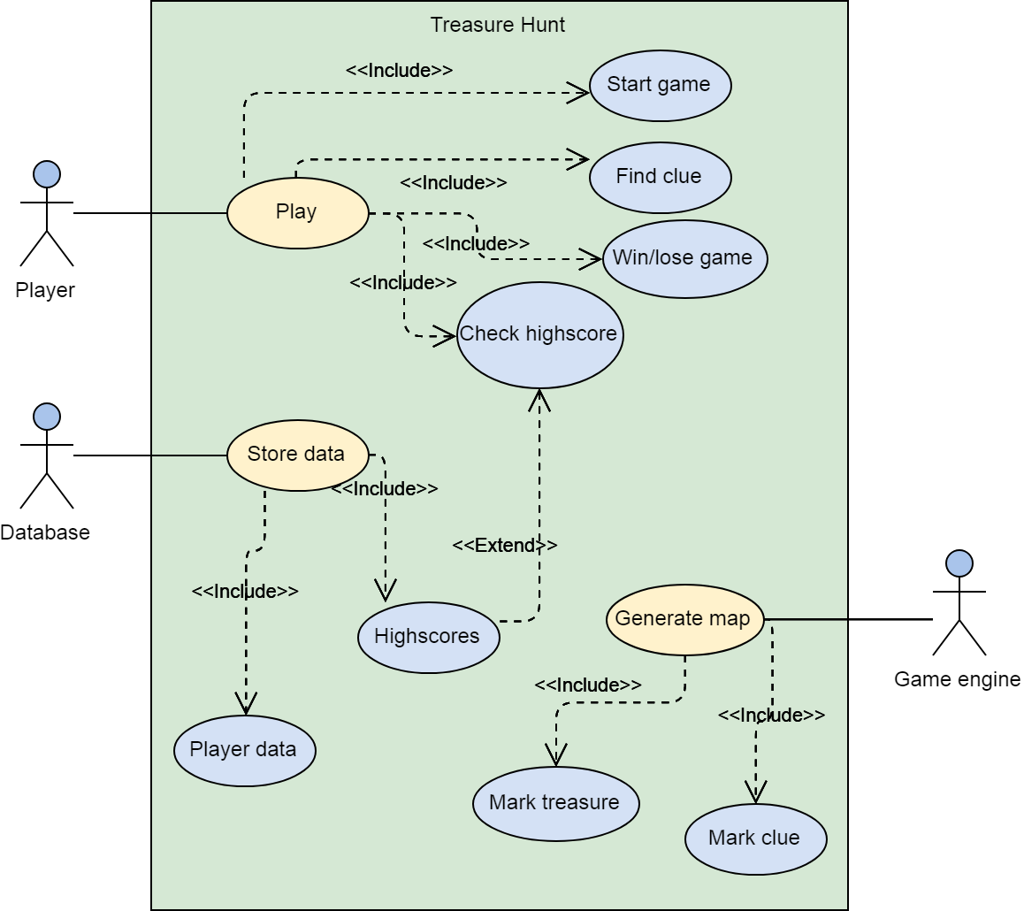

Figure 2: UML usecase diagram for Treasure Hunt game

3.3 Class diagram

The different classes in our project and their attributes and operations are clearly specified in the class diagram below.

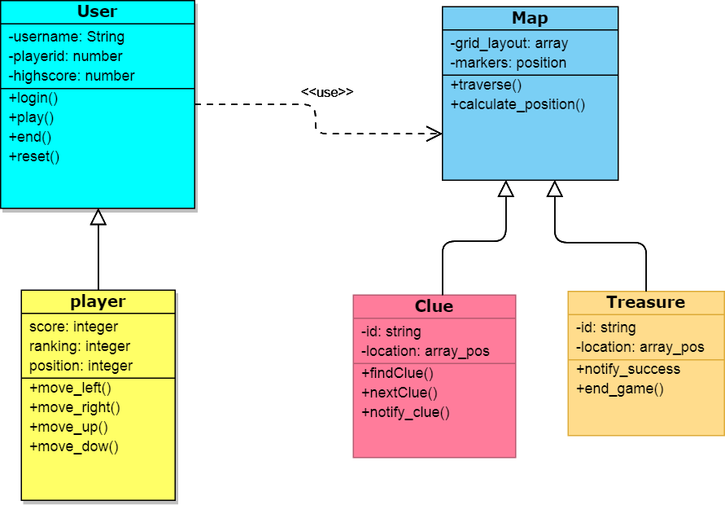

Figure 3: UML class diagram for Treasure Hunt game

4. TECHNOLOGIES USED

- Phaser framework: Phaser is a free software 2D game framework for making HTML5 games for desktop and mobile. It was created by Photon Storm. Phaser uses both a Canvas and WebGL renderer internally and can automatically swap between them based on browser support. This allows for fast rendering across desktop and mobile.

Canvas- The HTML <canvas> element can be used to draw graphics via scripting in
JavaScript. For example, it can be used to draw graphs, make photo compositions, create
animations, or even do real-time video processing or rendering. A page can effectively
add support for <canvas> by including a script from Google's Explorer Canvas project.
Google Chrome and Opera 9 also support <canvas>The <canvas> element is also used
by WebGL to draw hardware-accelerated 3D graphics on web pages,

Game constructor- This is where the magic happens. The Game object is the heart of your game, providing quick access to common functions and handling the boot process. During the setup we included the Phaser library in our HTML file. This gives us a global object called Phaser. Through it, we can access the library's methods and functions for building games. Now we will use the global Phaser object, and create a new game instance. This is an object which represents our entire game. We will add the states to it.

States- This is a base State class which can be extended if you are creating your own
game. It provides quick access to common functions such as the camera, cache, input.
match, sound and more. There are three main states namely, preload(), create(), and update(). There is also a fourth state commonly used which is named debug or renderer.

- JavaScript: JavaScript is a scripting language which is mostly used as part of the web browser. JavaScript is used in the HTML files to create functions , modify the content of the webpage(create, delete, update make it interactive) etc… JavaScript belong to objective oriented, imperative and functional programming styles therefore it’s a multi-paradigm language.

- HTML5: HTML5 is a markup language that is widely used to create web pages. Each HTML file is just a text file which is made up of HTML tags which will allow to add different content to the website and it has the extension of .html . HTML files can be connected by linking them together. The HTML tags are hidden keywords that defines and formats the content of the browser.

- JSON: JSON stands for JavaScript object notation, which is a lightweight data-interchange format. It is easy to machines to parse and generate. It’s based on a subset of the JavaScript Programing Language. JSON is text format and it is completely language independent. JSON is built on collection pairs and ordered list of values.

5. IMPLEMENTATION

5.1 Modules

- Game engine module - The game engine generates the game world with all the different components like the treasure map, the player and the treasure. It also draws the grid layout that helps in tracking the movement of the player and his proximity to the treasure. The grid layout has three outcomes: one, the player reaches the treasure without disturbance and wins the game, the player intercepts a baddie, dies and the game ends or if the player reaches an end of the map layout, the game engine automatically turns him around and back into the interiors.

- Player module - The player goes about the map in search of the treasure. A player can start, pause, resume and exit the game. The player searches for clues everywhere and tries to intercept the treasure. Depending on the difficulty of the level, the player may win or lose the game taking his own time. The player can even check his high score and others scores from the database.

- Database module - The database stores player details and common moves. It even stores high scores and ratio of win/losses. An upgrade to this module is a login for all players and different levels of difficulty set according to their high scores.

5.2 Sample code

<!DOCTYPE html>
<html lang="en">
<html>
<head>
<meta charset="UTF-8" />
<title>TreasureHunter</title>
<link rel="stylesheet" href="index.css">
<script src="js/phaser.min.js"> </script>

</head>
<body>
<script type="text/javascript">
var game = new Phaser.Game(640,640,Phaser.AUTO,'',{preload: preload, create: create , update: update});

var player;
var cursors;
var static;
var music;
var credits;

function preload()
{
game.load.image('background', 'assets/background.png');
game.load.spritesheet('dude', 'assets/dude.png',32,48);
game.load.image('treasure', 'assets/treasure.png');
game.load.audio('bgm', 'assets/audio/bgm.mp3');
game.load.video('credits','assets/credits.mp4');

}

function create()
{

// game.physics.startSystem(Phaser.Physics.ARCADE);
game.physics.startSystem(Phaser.Physics.P2JS);
// game.physics.arcade.checkCollision = true;

game.add.sprite(0,0, 'background');

music = game.add.audio('bgm');
music.play();

// player
player = game.add.sprite(0,0,'dude',5);
// game.physics.arcade.enable(player);

// game.physics.p2.enable(player);

goal = game.add.sprite(622,288, 'treasure');
goal.scale.setTo(1.2);
goal.body.static = true;

player.animations.add('left',[0,1,2,3],10,true);
player.animations.add('right',[5,6,7,8],10,true);

cursors = game.input.keyboard.createCursorKeys();

goal.body.onBeginContact.add(collideHandler, this);
}

function collideHandler(body, bodyB, shapeA, shapeB, equation)
{
// console.log("Yay! You've won!");
// game.music.kill();
alert("Yay! You found my shoes!");
game.world.removeAll();
}

function update()
{
player.body.velocity.x = 0;
player.body.velocity.y = 0;

if(cursors.left.isDown)
{
player.body.velocity.x = -400;
player.animations.play('left');
}
else if(cursors.right.isDown)
{
player.body.velocity.x = 400;
player.animations.play('right');
}
else if(cursors.up.isDown)
{
player.body.velocity.y = -400;
player.animations.play('up');
}
else if(cursors.down.isDown)
{
player.body.velocity.y = 400;
player.animations.play('down');
}
else {
player.animations.stop();
player.frame = 4;
}
}

</script>

<span><img src="assets/title.png" height="250" width="350"></span>
<span id="credits">
<img src="assets/logo.png" height="150" width="220">
<h2>A product by</h2>
<h3>Group A19</h3>
<br>
</span>
<br><br>

<div>
Hi! My name is Bucky. I am quite forgetful. I seem to have lost something, but I can't remember what. Can you help me find it?<br>
What can you see in the map below that could possibly belong to me?
</div>

<div class="fade-in">
Hint: Are you getting cold feet? Don't lose hope! I think I lost something I wear on my body. It's strange I know.
</div>

</body>
</html>

5.3 Output Screens

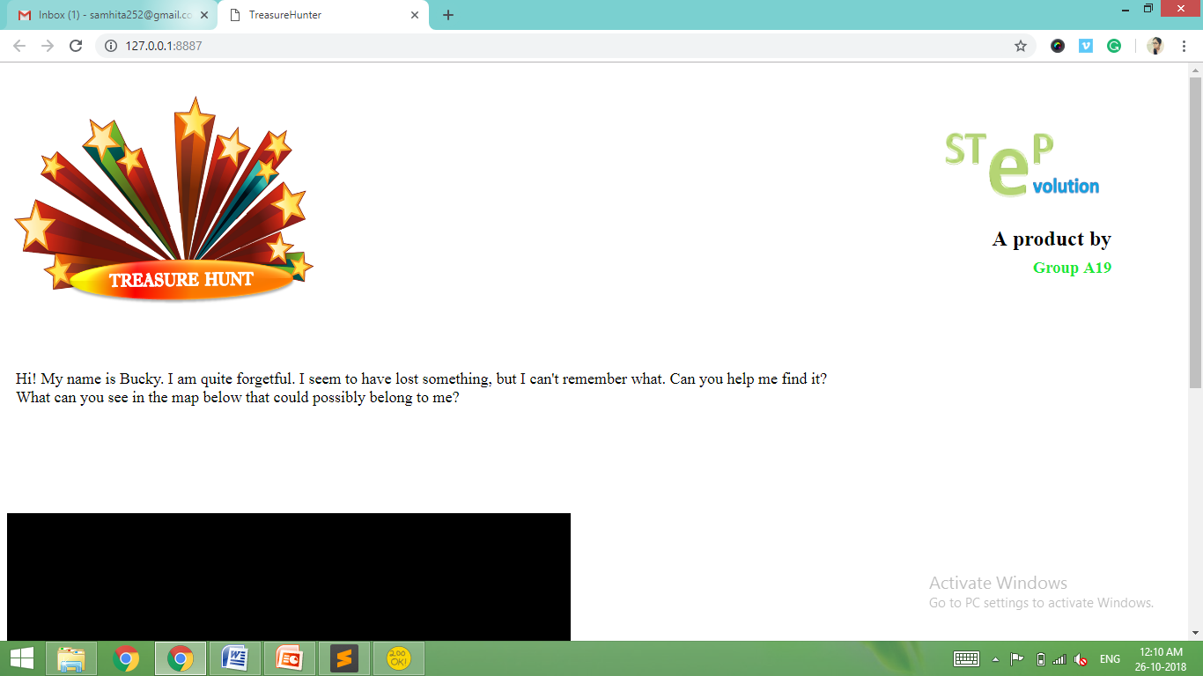

Figure 2: Website layout

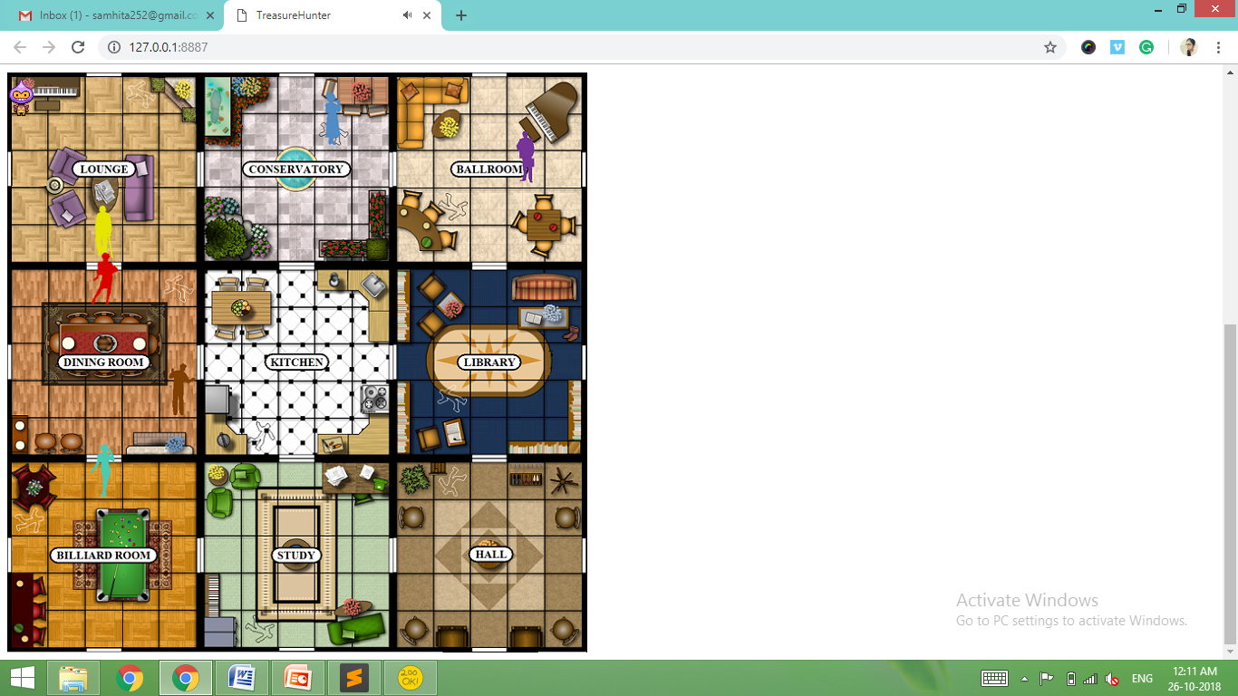

Figure 3: Game world created

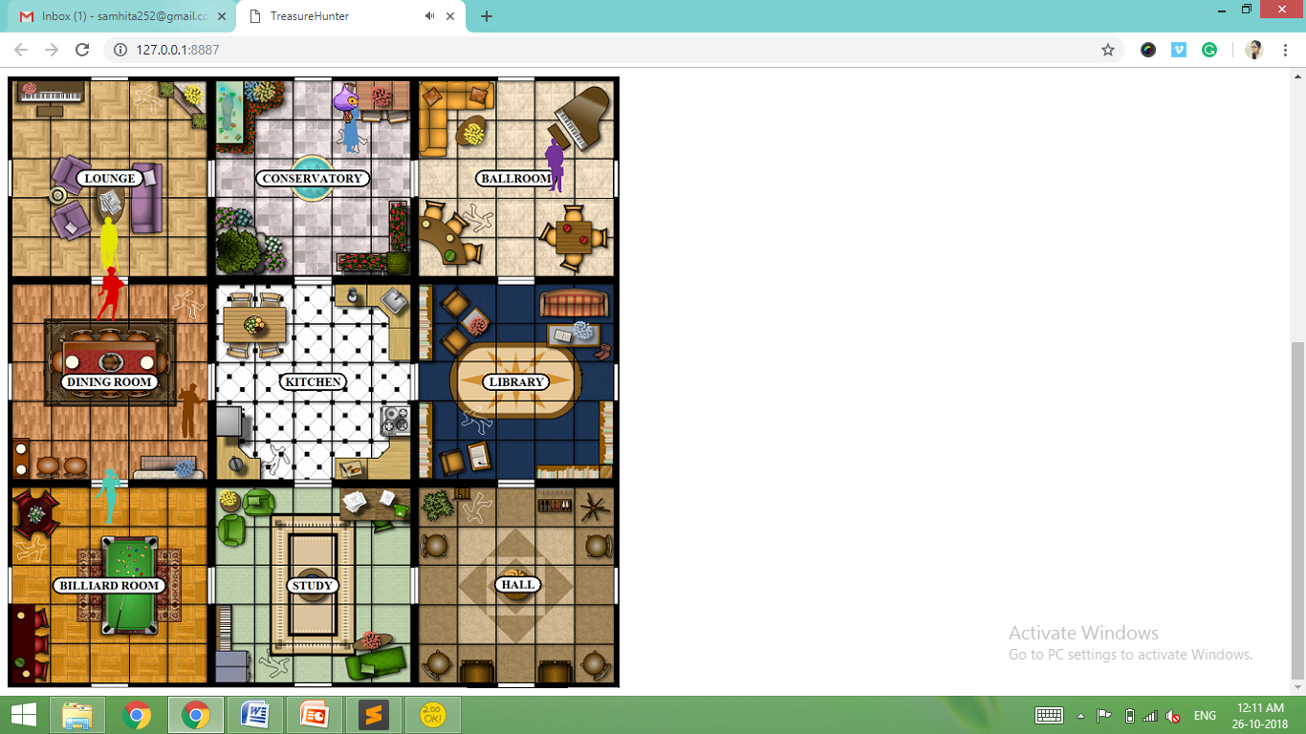

Figure 4: Player moves

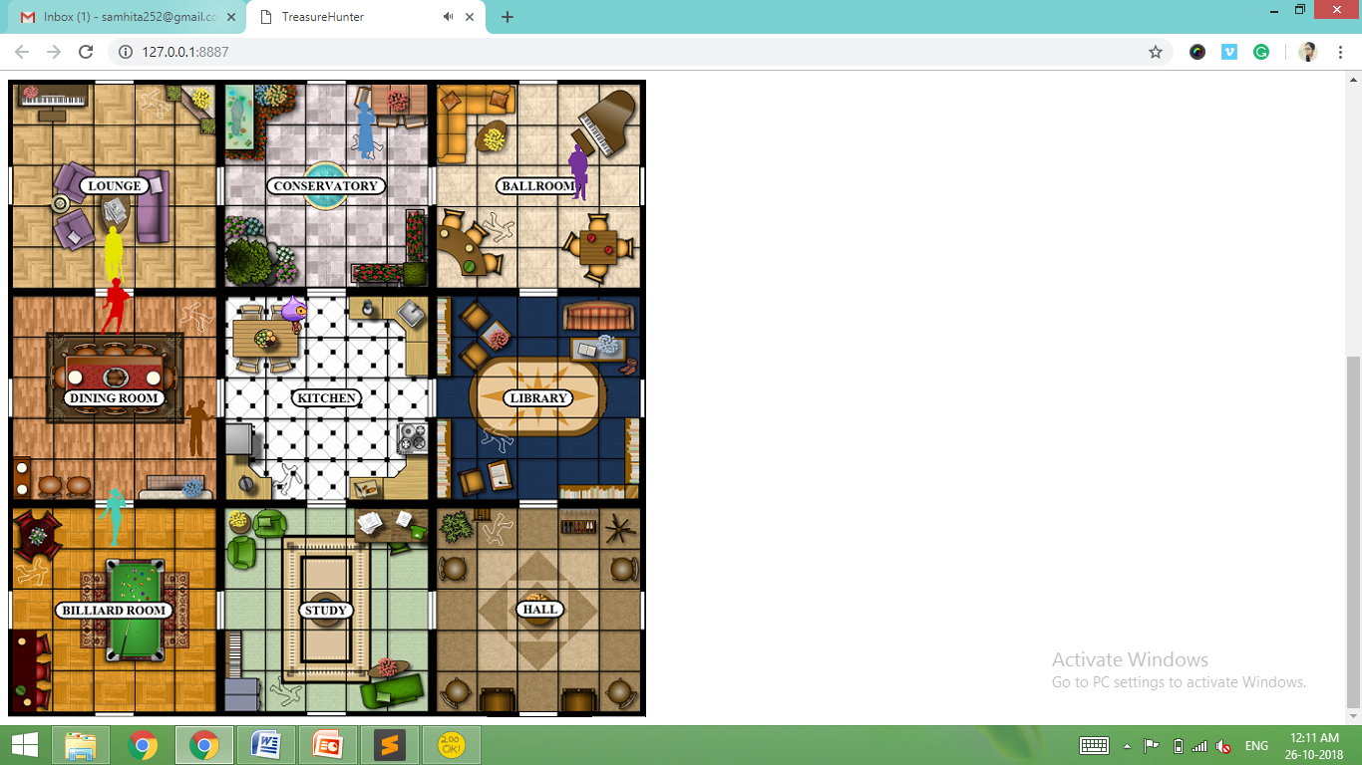

Figure 5: Player searches

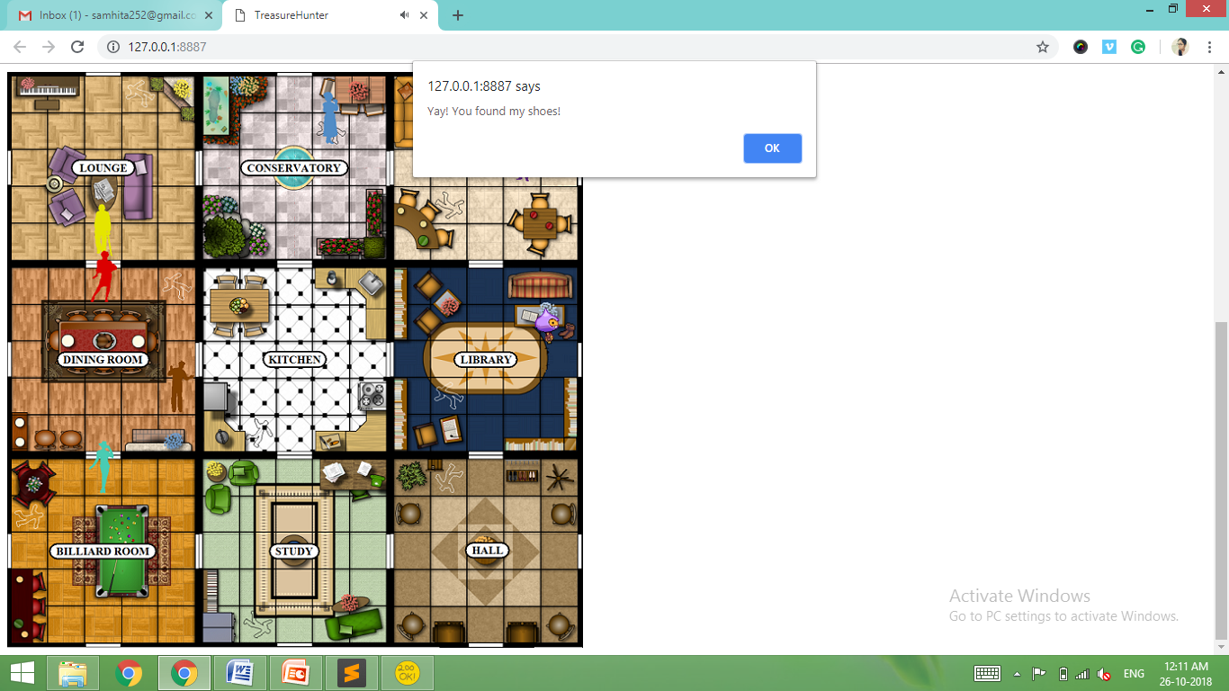

Figure 6: Player finds treasure

6. CONCLUSION AND FUTURE ENHANCEMENTS

Conclusion

The treasure hunt game is an easy to play, simple UI and fun game to play. People of all ages can try this game. This game is only for recreational purposes. All the coding for this project has been done by the team A19. The different modules all fit together and work well. The game is an overall success.

Scope for Future enhancements

This release is Treasure Hunt 1.0. Upgrades to this version can be levels of difficulty, user login and unlocking game hints. The treasure map can also be made with increased complexity with single or multiple treasures and varying with each game. Bucky can be assigned to finding even more items along the map.

7. REFERENCES

Textbooks

[1] Travis Faas, An Introduction to HTML5 Game Development with Phaser.js, 1 edition, A K Peters/CRC Press, 2016.
[2] Stephen Gose, Game development guide using Phaser JavaScript G, 2016.

URLs

[1] https://gamedevacademy.org/phaser-3-tutorial/
[2] https://phaser.io/examples
[3] https://phaser.io/learn/official-tutorials

